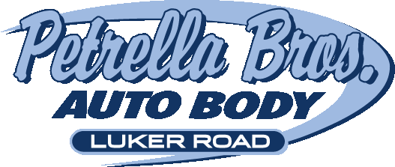

Accident Plan
KEEP THIS IN YOUR GLOVE BOX with your insurance card.

CALL PETRELLA BROS. AUTO BODY: 607-756-9388
WE CAN ARRANGE A TOW FOR YOU WITH MOREY TOWING.

Immediately tend to any injured parties and call the POLICE. Use caution in the roadway AND move off the road. If available, use emergency flairs to alert other drivers.

- Only explain the accident to the Police.
- Don’t argue with anyone. Anything you say may be used against you later.
- Ask that the vehicle be towed to PETRELLA BROS. AUTO BODY located at 3812 LUKER ROAD IN CORTLAND.
- Call US before you call your insurance company for more important info and guidance.
- Exchange information with the other driver AND get a copy of the police report.

Expect that your insurance company will try to steer you to their “preferred shop.” Tell them; “PETRELLA BROS. AUTO BODY IS MY PREFFERED SHOP.”

Accident Notes:

Date: _________________ Time: ______________ Location: ________________

Other Driver’s Name: __________________________________________________

Address: ____________________________________________________________

City: ______________________ State: ______________ Zip: ________________

Yr. of Vehicle: __________ Make: _________________ Model: ______________

License Plate: __________________ Drivers License ID: ____________________

Insurance Co: __________________________ Agent: _______________________

Policy #: __________________________ Police Officer: _____________________

It is my request that my vehicle be towed to:
PETRELLA BROS. AUTO BODY, 3812 LUKER ROAD, CORTLAND, NY

x _________________________________________
Customer Signature (sign and print name)

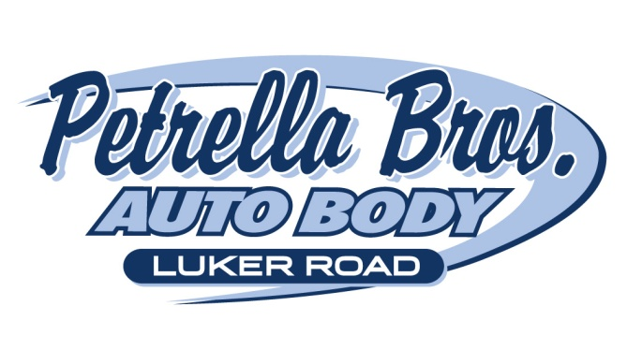
3812 Luker Road Cortland, New York 13045
607-756-9388 fax: 607-756-8004
matt@petrellas.com
www.petrellas.com

A few things to remember during your claim process:

PURSUANT TO SECTION 2610 OF THE NEW YORK STATE INSURANCE COMPANY LAW, INSURANCE COMPANY MAY NOT REQUIRE THAT REPAIRS BE MADE TO A MOTOR VEHICLE IN A PARTICULAR PLACE OR REPAIR SHOP. YOU HAVE A RIGHT TO HAVE YOUR AUTOMOBILE REPAIRED IN THE SHOP OF YOUR CHOICE. INSURANCE COMPANY CANNOT REQUIRE YOU TO RECEIVE MULTIPLE ESTIMATES OR DIRECT YOU TO A SPECIFIC SHOP FOR AN ESTIMATE.

In the event we have prepared an estimate for you on your vehicle and an insurance adjustor comes to you to prepare an estimate and his/her estimate is less than ours, DO NOT PANIC. This does not mean that we cannot repair your vehicle; it is only a preliminary estimate. Some insurance companies will not write for specific items in the field, they full well expect to have us contact them when the vehicle is in for repairs to discuss omitted items. All you need to do is bring us the estimate from the insurance company; we will review it with you and contact the insurance company in the event they have missed any damage.

We encourage you to have your car here at our shop for the adjustor to look at. We can explain the repair process to the adjustor and get an agreement on site. This will save you time and ensure that your vehicle is repaired properly.

We look forward to working with you and for you to get your vehicle back to its pre-accident condition. We would be happy to assist you in handling your claim.

Please do not hesitate to call us with any questions that you may have.

